
GCT Group Transformation Strategy 2026+

Strategic Review & Implementation Proposal
Prepared by DSG | Confidential – For GCT Group Executive and Board Review
02/19/2026

Contents
1. Executive Summary 3
2. Background and Context 3
3. Why DSG? 4
4. Strategic Review Approach 6
5. Design 7
6. Build and Operate 9
7. Transfer 11
8. Deliverables 13
9. Resource Plan and Timeframe 13
10. Investment and Commercials 14
11. Next Steps 15

Executive Summary
GCT Group stands at a pivotal inflection point — transitioning from a traditional fibre ISP to Nigeria’s first fully converged, cloud-enabled, customer-centric digital telecoms service provider.
DSG proposes a Design-Build-Operate-Transfer (DBOT) partnership that delivers measurable outcomes:
- Sustainable revenue growth through diversified product innovation.
- Operational efficiency through automation and digital process redesign.
- Customer excellence through data-driven engagement and omnichannel experience.
This partnership will create a future-ready GCT Group MVNO — financially strong, digitally agile, and strategically positioned to lead Nigeria’s telecom renaissance.

Background and Context

Executive Overview
GCT Group has built a formidable reputation as one of Nigeria’s leading fibre-to-the-home (FTTH), enterprise connectivity, and data centre service providers. With a strong presence in key urban centres such as Lagos, Abuja, and Port Harcourt, GCT Group is already positioned as a premium connectivity brand trusted by residential and enterprise customers.
The next logical strategic evolution for GCT Group is the addition of a Mobile Virtual Network Operator (MVNO) capability — enabling GCT Group to offer fully integrated fixed-mobile convergence (FMC) services under its own brand.
This proposal outlines how launching an GCT Group Mobile MVNO will:
- Expand Average Revenue Per User (ARPU)
- Reduce churn across fibre and enterprise customers
- Strengthen brand stickiness
- Unlock new B2C and B2B revenue streams
- Position GCT Group as a full digital connectivity provider
Why an MVNO Makes Strategic Sense for GCT Group
Nigeria’s telecom market is mature but still highly mobile-first:
- Over 200 million mobile subscriptions
- Data consumption growing double digits annually
- Increasing demand for bundled connectivity
- Growing SME digitisation
Yet most ISPs remain fixed-line providers only.
By launching an MVNO, GCT Group would become a converged digital connectivity operator — similar to global ISP-to-MVNO evolutions seen in Europe and Asia.
Strategic Rationale
1. Fixed-Mobile Convergence (FMC)
GCT Group already owns the fixed broadband relationship. Adding mobile allows:
- Bundled Fibre + Mobile data packages
- Shared data pools for households
- Unified billing
- Cross-selling
- SIM-enabled backup connectivity for fibre outages
This dramatically reduces churn and increases lifetime value.
2. Enterprise & SME Upsell
GCT Group serves many corporate clients. An MVNO enables:
- Corporate mobile fleet packages
- IoT SIMs
- M2M connectivity
- Backup LTE failover for enterprise fibre
- Closed User Groups (CUGs)
This strengthens enterprise contracts and defends against MNO encroachment.
3. Residential Cross-Sell Opportunity
GCT Group fibre households are prime candidates for:
- Value based mobile bundles
- Family SIM packs
- Mobile data rewards linked to fibre usage
- Loyalty-driven bundles
Mobile becomes a retention tool rather than just a revenue line.
4. Asset-Light Expansion
An MVNO model allows GCT Group to:
- Avoid spectrum and RAN investment
- Leverage an existing MNO network (MTN, Airtel, Glo, etc.)
- Focus on brand, billing, customer experience, and bundling
- Launch within a few months
Capex remains controlled while revenue diversifies.
Proposed GCT Group MVNO Positioning
Brand Concept:
“GCT Group One Network” – Seamless Home, Office & Mobile Connectivity
Core Pillars:
- Converged connectivity
- Premium customer experience
- Enterprise-grade reliability
- Transparent pricing
- Data-led loyalty rewards
- Value added services – Travel eSIM, Cyber Security through Bit Defender,
Revenue Model Overview
Key Revenue Drivers:
- Prepaid mobile data bundles
- Postpaid/Prepaid SME contracts
- IoT connectivity
- Device financing
- Cross-sell uplift to fibre base
- Reduced fibre churn
Financial Uplift Potential:
- 10–15% ARPU uplift on existing fibre customers
- 5–10% churn reduction
- New subscriber growth beyond fibre footprint
Competitive Differentiation
Unlike traditional Nigerian MNOs, GCT Group can offer:
Traditional MNO | GCT Group MVNO Advantage
Mobile-only | Fixed + Mobile convergence
Mass market | Premium urban segment
Generic bundles | Converged smart home bundles
Limited enterprise integration | Full ICT + fibre + mobile integration
GCT Group can occupy the premium converged ISP-mobile niche, similar to European fibre-led operators.
Implementation Framework
Phase 1 – Strategy & Commercial Modelling
- Target segments
- Bundle design
- MNO host negotiation
- Financial modelling (5-year forecast)
Phase 2 – Technical Enablement
- Billing integration
- CRM integration
- OCS & provisioning
- KYC compliance in Nigeria
Phase 3 – Soft Launch
- Pilot to staff
Phase 4 – Full Commercial Launch
Why Now?
- Nigeria’s data demand continues to accelerate
- Fibre players must defend against mobile-first competitors
- FMC is underdeveloped in Nigeria
- Enterprise digital transformation is accelerating
- Customer acquisition costs are rising — convergence reduces CAC
Strategic Outcome
Launching an MVNO positions GCT Group to:
- Transition from ISP to Digital Connectivity Operator
- Strengthen valuation multiples
- Increase EBITDA margins through bundled revenue
- Create long-term defensive positioning against mobile incumbents

Why DSG?

We partner with our customers across Africa to build comprehensive solutions, which innovate business relationships to yield mutual return on investment. Our people and diverse technology enable anywhere, anytime access to products and services ensuring a customer centric focus. DSG serves and manages digital transformation for large consumer facing brands, and we are responsible for the execution of their strategy.

 | 
 | MVNE (Mobile Virtual Network Enabler) – Provides mobile virtual services for large consumer-facing brands seeking to integrate mobile into their strategy, includes unique consulting and comprehensive MVNO Commercial Viability analysis. | - Commercial Viability analysis  - MVNO platform and ecosystem management  - VAS  - Insurance  - OTT  - Cloud Storage  - Security  - eSIM  - Travel eSIM  - Loyalty Programs  - Devices  - Device Financing  - Safe Family (McAfee)  - Sentiance (UBI)  - MARS – revenue assurance
 | CXG (Customer Experience Group) – Integrated customer experience solutions, aimed at consumer-facing organisations seeking cost-effective, prioritised CX strategies, including contact centre, social media, whatapp, sms, email channels, leveraging a world class tech stack. | - Omni Channel support  - CX (Customer support)  - Customer Care  - Social Media engagement  - IT service desk and management  - Contact Centre Services  - Workforce Management  - Dynamic CRM Solutions  - Business Intelligence and deep domain insights
 | Digitalise – A design and development studio delivering made‑to‑fit user experiences aligning with brand and CX objectives. | - Digital Transformation  - Social CRM and online reputation  - SEOP and PPC management  - Enterprise workforce management  - Web development  - App development
 | BroadBrand – A mobile media marketing solution harnessing AI and mobile moments to build customer relationships, including the Xanite (CVM) customer engagement platform | - MaaS 3  - AI-Driven Strategy Development  - Content Creation Powered by AI  - AI-Enhanced Digital Advertising  - SEO and SEM with AI Insights  - Social Media Management with AI  - Analytics, Reporting, and AI Tool Reselling  - Xanite – CVM
 | digitalmall.com – A turnkey e‑commerce technology partner, allowing brands to launch online stores without complexity or high overheads | - Online e-Commerce services
 | Digital Resilience – Cybersecurity solutions with fully managed security services for enterprises, SMEs, and McAfee for consumers. | - Enhanced Digital Security Solutions  - Custom Cyber Defence Solutions  - Comprehensive Risk Management
 | eInsurer – Cyber insurance solutions tailored for both corporates and individuals. Offers detailed risk management and adaptive protection. | - Identity theft protection  - Data restoration  - Cyberbullying coverage  - Cyber extortion

Strategic Review Approach

DSG’s approach is structured across seven clear phases:
1. Strategic Thinking Sessions – Workshops with Exco to explore trends, opportunities, and internal insights. (Design)
2. Strategy Direction – Define goals, pillars, and strategic priorities. (Design)
3. Planning & Implementation Framework – Translate strategy into operational actions. (Design)
4. Revised Strategic Plan – Integrate feedback and finalise roadmap. (Design)
5. Board Pack & Approval – Present final plan for endorsement and execution. (Design)
6. Execution of strategy and business operations. (Build and operate)
7. Transfer operations to GCT Group. (Transfer)

Each phase of the DBOT model is designed to unlock tangible business value:

- Design: Strategic clarity and commercial validation.
- Build: Digital and operational enablement.
- Operate: Performance optimisation and governance.
- Transfer: Capability independence and scalability.

This structured approach ensures continuity from vision to execution with measurable KPIs and board-level visibility at every stage.

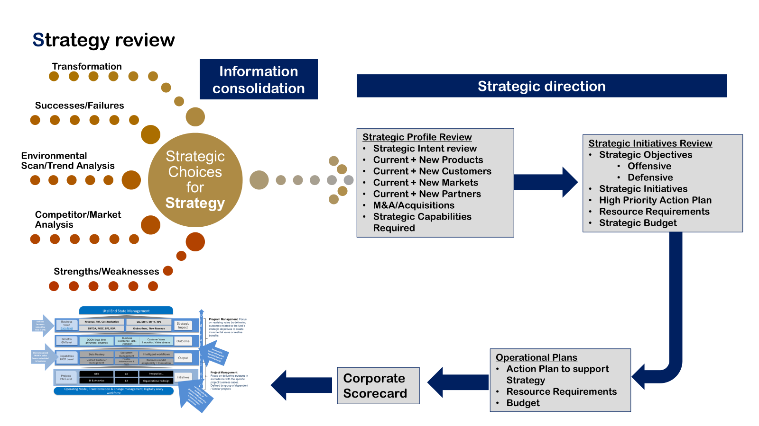

Design

The Design Phase lays the foundation for execution by translating strategy into measurable business outcomes. It ensures alignment between market opportunity, operational capability, and financial ambition. We work with the GCT Group executive team on a comprehensive Strategic Review to define what the needs are in consumer, business and wholesale segments and work through a nine-step process to build a business that can deliver on these needs in the most efficient way.
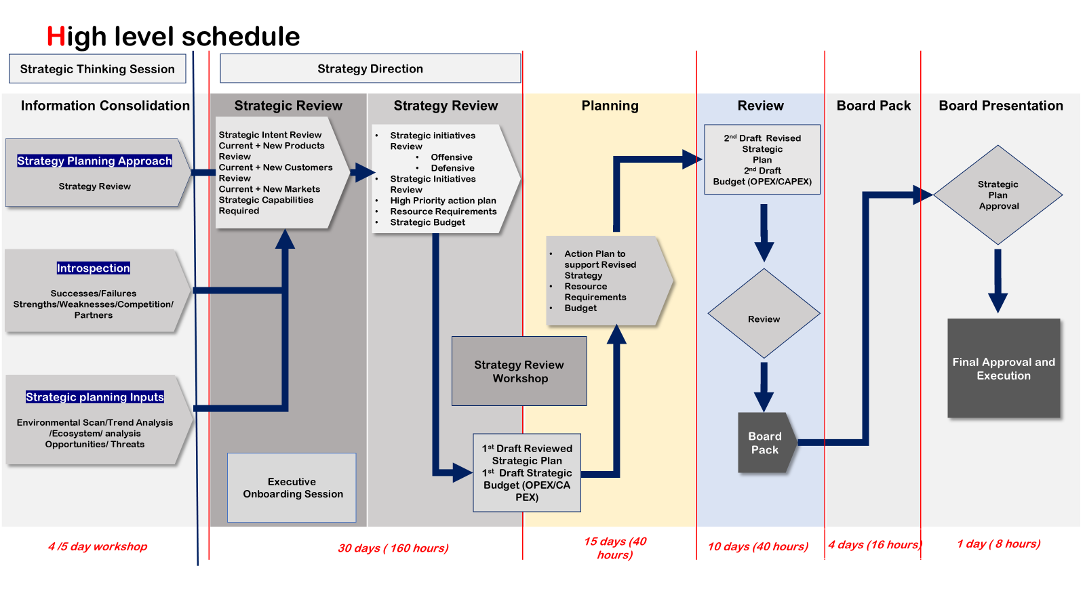
Duration: 1–8 weeks
• Weeks 1–2: Workshops & Direction
• Weeks 3–5: Draft Plan Development
• Weeks 5–7: Implementation Roadmap
• Weeks 8: Final Approval & Presentation
DSG will deploy senior consultants, analysts, and facilitators, working closely with GCT Group’s leadership. An executive lead from MVNE will be available full-time two weeks a month to guide the Design process.
The deliverables for this stage of the engagement will be as follows:
- Define MVPs¹ and roadmap to deliver GCT Group products and services, hosted by GCT Group.
- Define a high-level OM² and GTMP³ for the proposed MVPs¹ for GCT Group as a core business proposition, taking into consideration the various verticals.
- Define a high-level desired ICX⁴ across the customer lifecycle to articulate customer care, consumer self-care and related service experiences required by GCT Group to ensure an experience in line with brand expectations.
- Build a granular 60-month BM⁵ defining the investment requirement, likely performance of the business, cash flow and commercial break-even parameters and expected returns-on-investment including:
  - GCT Group Capex and Opex costs
  - Peak funding requirements
  - Expected break even and cash flow positive estimates
- Define the parameters for a full launch to articulate any further investment requirements to target and address the needs of the customer segments identified through strategy derivation.
DESIGN PHASE - DELIVERABLES
MVP¹ | Packages, Deals and specific products and services that will be sold at relaunch, forming a Minimum Viable Proposition.
GTM² | A Go-to-Market plan, including Brand, Sales, Distribution, Customer Care and Subscriber Life Cycle Management
OM³ | An Operating Model, including a high-level Technical Architecture & relational diagram between Parties defining the functional responsibilities.
ICX⁴ | An Integrated Customer Experience, including Customer Journeys and high-level business processes.
BM⁵ | A granular, 60-month business plan & commercial analysis
Notes
1 MVP – Minimum Viable Proposition; ^{2 OM – Operating Model;} ^{3 GTMP – Go To Market Plan;}
4 ICX – Integrated Customer Experience; ^{5 BM – Business Model.}
DSG’s methodology ensures GCT Group’s strategy is commercially viable, technically sound, and operationally executable before any investment is deployed.

Build and Operate

Implementation of the strategic plans.

The Build and Operate phase activates the transformation blueprint.
DSG establishes a dedicated Transformation Project Office (TPO), co-led by GCT Group’s leadership, responsible for implementing the agreed roadmap and delivering measurable outcomes across key performance levers:
• Revenue growth
• Cost efficiency
• Customer experience
• Digital adoption
• Network performance
DSG embeds senior experts alongside GCT Group’s teams to ensure skills transfer, agile delivery, and rapid impact. The TPO model guarantees execution discipline, governance visibility, and delivery confidence for the CEO and Board.
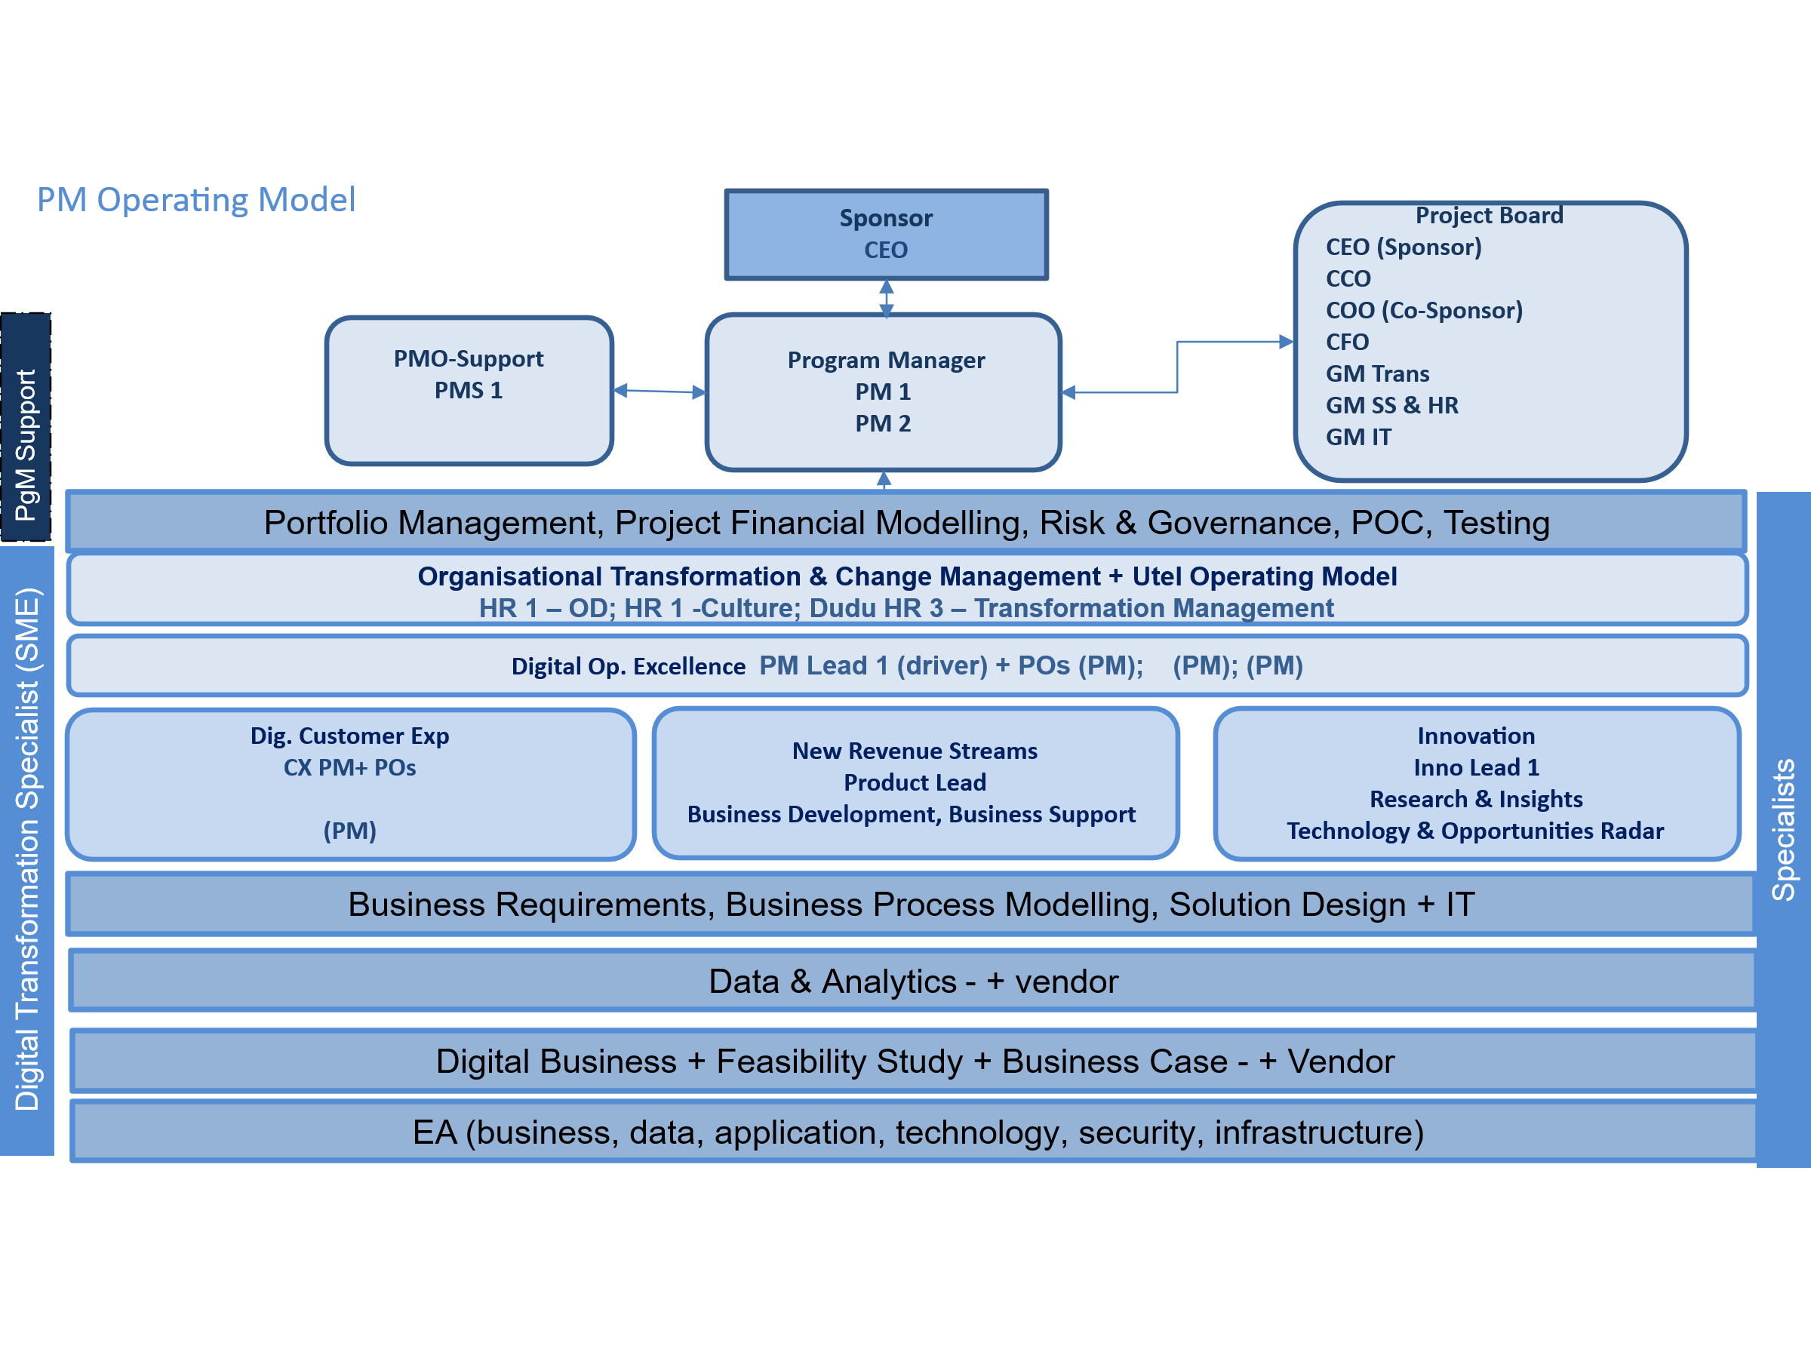
TPO
The project office will be responsible for delivering on the key objectives of the business strategy as defined from the Design process:
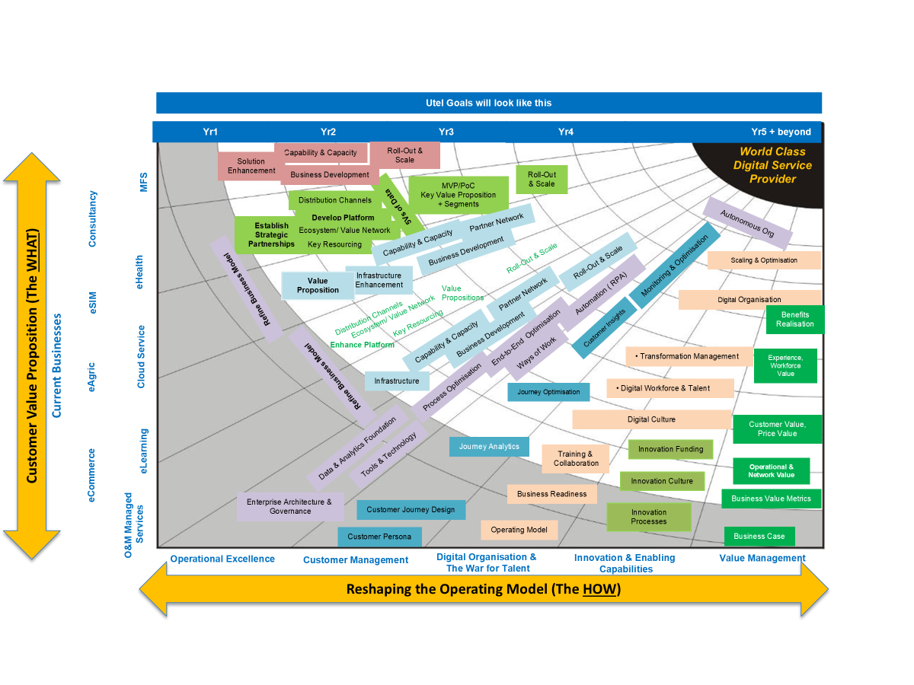
The project office will also be responsible for ensuring that KPIs and value levers are driven throughout the business to meet the defined objectives from the strategy.
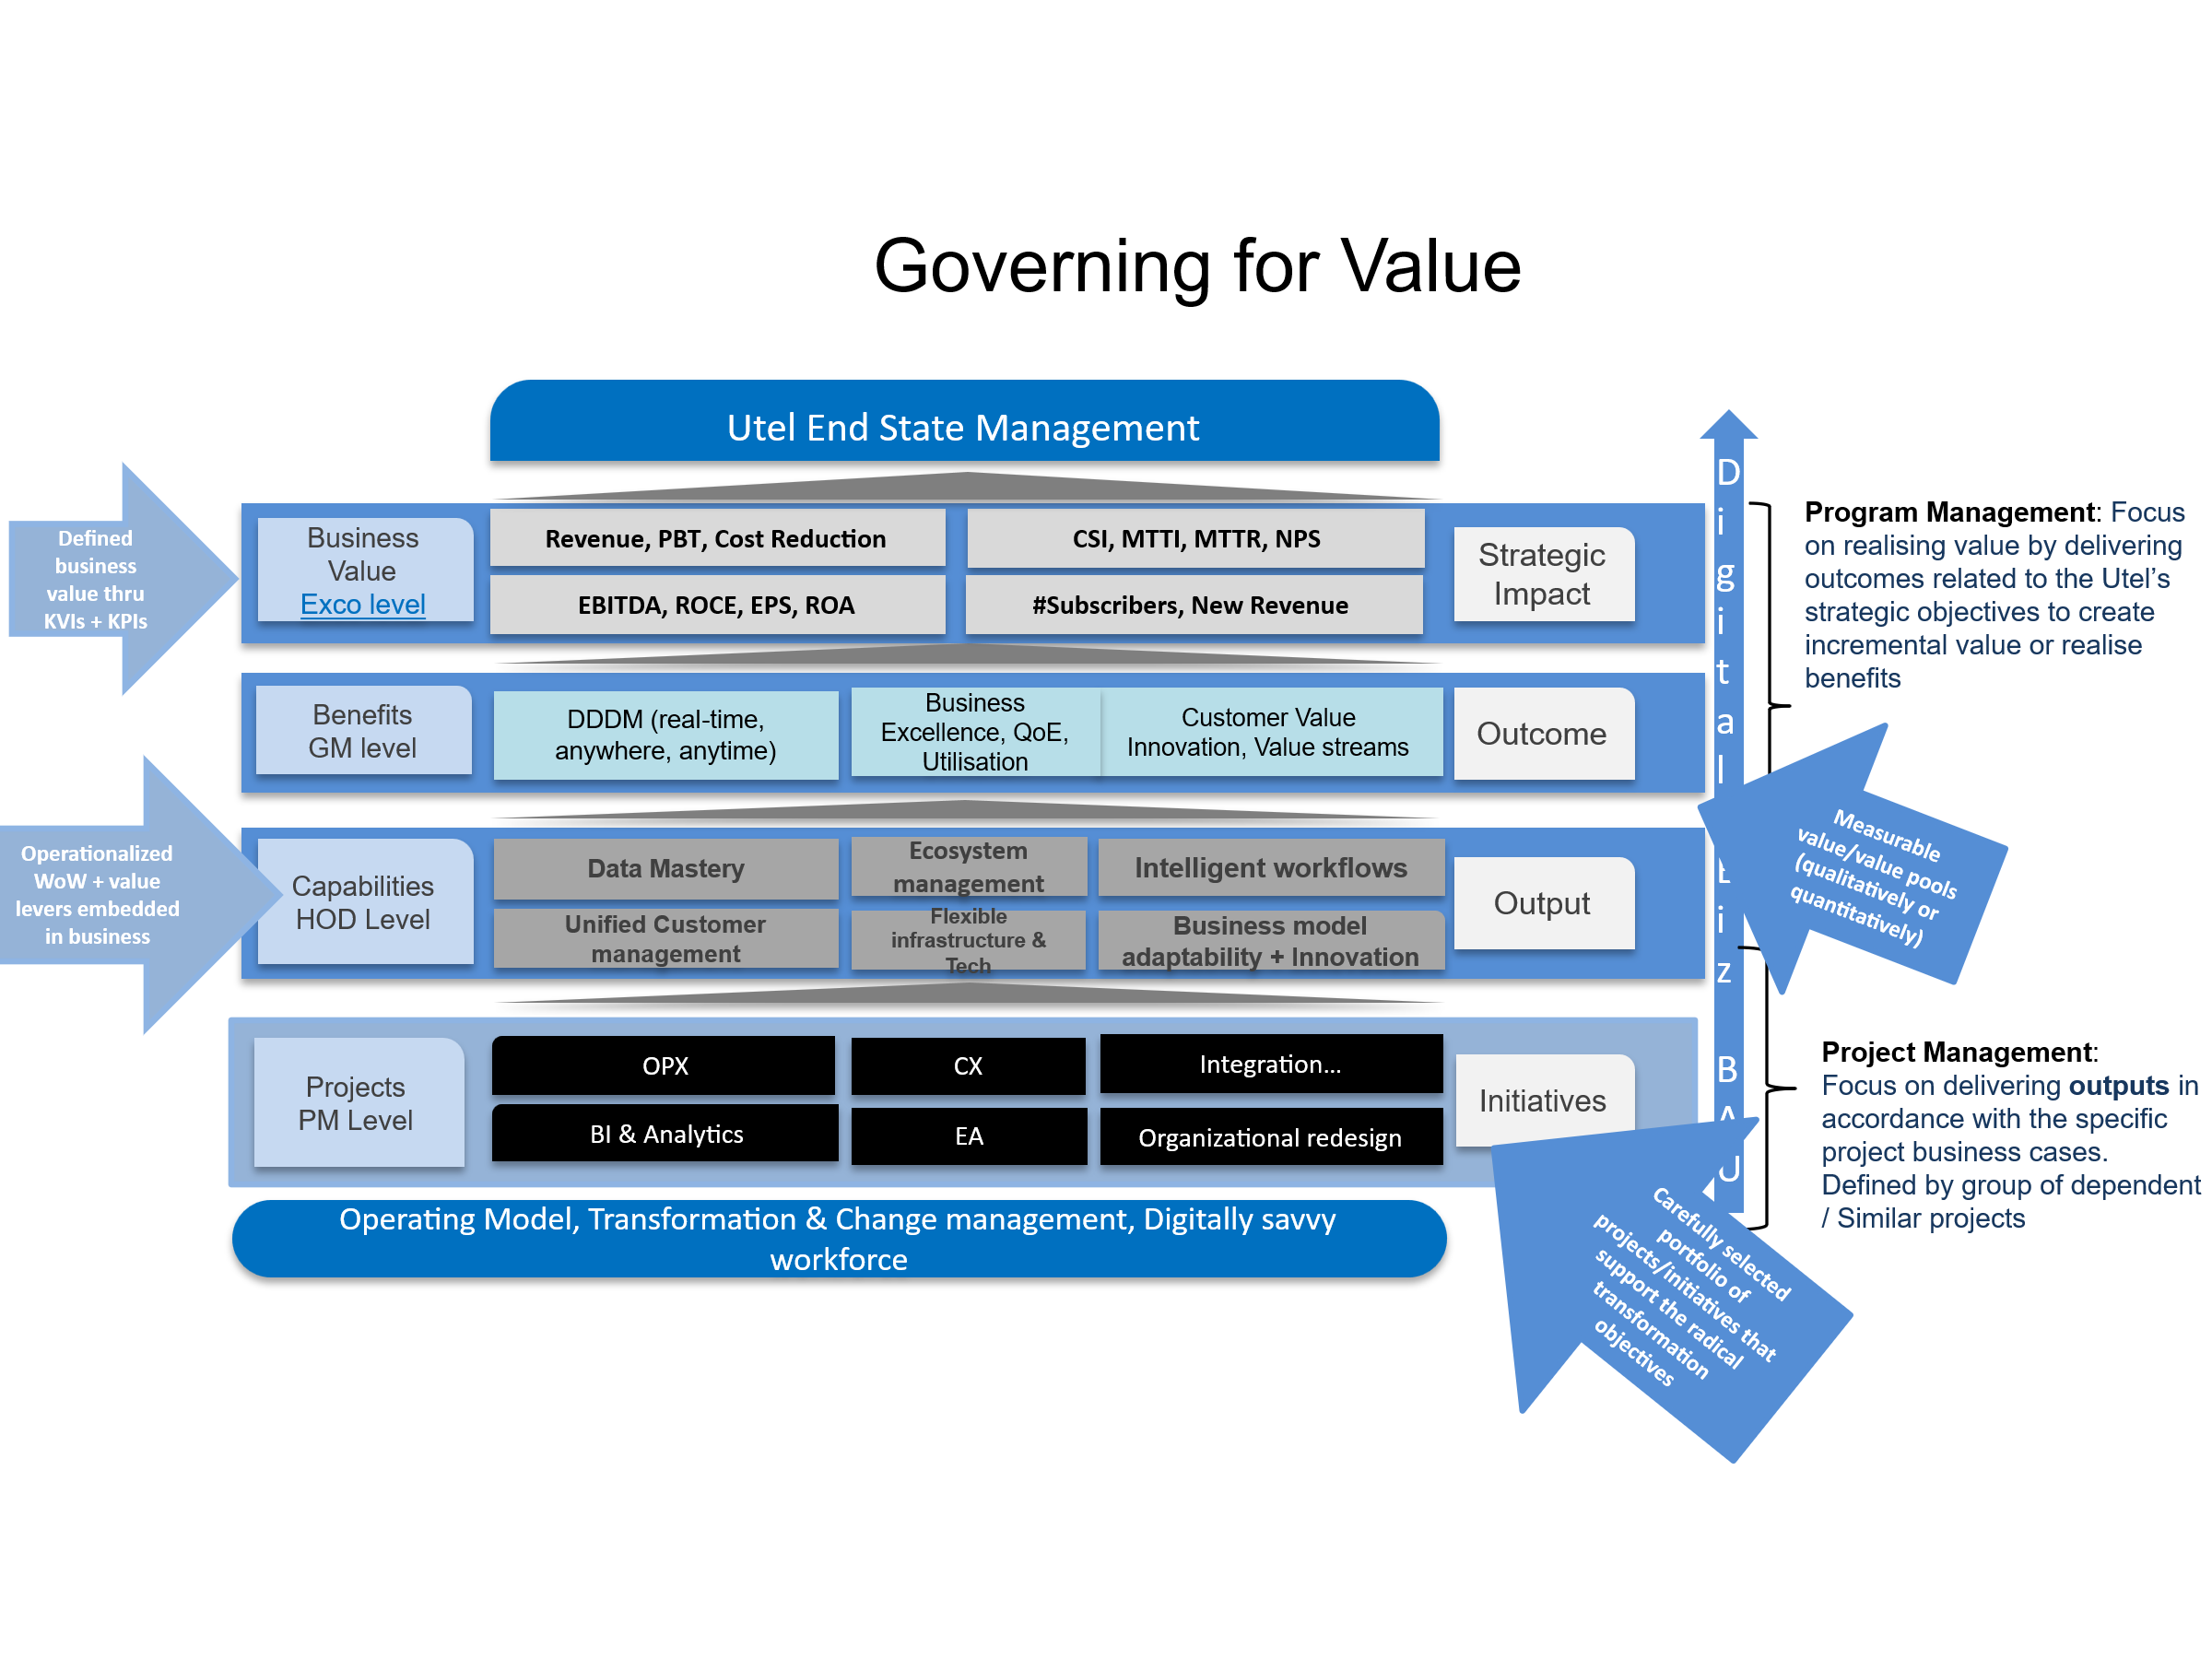
DSG will deploy senior consultants, analysts, and facilitators, working closely with GCT Group’s leadership. An executive lead from MVNE will be available full-time, two weeks a month to guide the Build and Operate process.
Once the Design process is complete DSG will have a closer idea of timelines and the number of resources and time that will be required to deliver on the strategy. The initial estimation is that DSG will require at least 6 months involvement in the Build and Operate phase.

Transfer

Purpose
The Transfer Phase marks the culmination of the Design-Build-Operate-Transfer (DBOT) engagement, transitioning full operational control of the newly modernised GCT Group platform, systems, and processes from the MVNE team to the GCT Group’s internal management. This phase ensures GCT Group inherits a fully optimised, scalable, and self-sufficient operation with the knowledge, systems, and capabilities to sustain growth and innovation independently.
The success of the Transfer Phase will be measured by three key indicators:
- Operational independence — 100% of systems and processes managed internally.
- Commercial performance — delivery of agreed KPIs over 90 days.
- Leadership capability — full operational confidence by GCT Group’s management team.

This marks the transition from dependence to digital sovereignty — ensuring GCT Group is self-sufficient, competitive, and future-proof.

Strategic Objectives

- Knowledge and Capability Transfer: Equip GCT Group’s leadership, operations, and technical teams with the competencies required to manage, optimise, and evolve the end-to-end ecosystem.
- Operational Continuity: Ensure a seamless transition with zero disruption to customer experience or business continuity.
- Governance and Handover Assurance: Implement clear documentation, sign-off criteria, and performance validation to confirm readiness for full transfer.
- Future Independence: Enable GCT Group to confidently operate as a digital-first, customer-centric, and commercially agile MVNO post-handover.

Design of the Transfer Framework

The Transfer phase is structured into five integrated streams:

- Operational Readiness
  - Comprehensive system audits and health checks.
  - Final stabilisation of OSS/BSS, CVM, billing, CRM, and data platforms.
  - Verification of SLAs and KPI compliance over a 90-day operational validation window.
- Knowledge & Skills Transfer
  - Deployment of structured training programs, including:
    - Executive leadership workshops (strategy, performance dashboards, innovation governance)
    - Functional team shadowing (network operations, product management, customer experience)
    - Technical knowledge transfer (architecture blueprints, API catalogs, data models)
  - Creation of a “Transfer Playbook” for each domain, detailing operational procedures, escalation matrices, and optimisation levers.
- Documentation & Governance
  - Delivery of all technical and operational documentation, including:
    - Architecture diagrams, workflow maps, and configuration logs.
    - Process documentation, SOPs, SLAs, and system ownership records.
  - Governance structure defining post-transfer accountability, reporting cadence, and change control.
- Performance Benchmarking & Validation
  - Measurement of key commercial and operational indicators over the final 90-day transition:
    - ARPU, churn, network uptime, service activation, and customer satisfaction metrics.
  - Joint performance validation and final acceptance sign-off by GCT Group and MVNE leadership.
- Exit & Support Assurance
  - Provision of a 3–6-month post-transfer support period.
  - Establishment of escalation channels for post-handover issues.
  - Final “Go-Independent” certification confirming successful transfer and full operational autonomy.

Implementation Roadmap

Phase | Duration | Key Activities | Deliverables
T1 – Preparation & Planning | Weeks 1 | Define transfer scope, finalise audit findings, agree success metrics. | Transfer Plan, Acceptance Criteria
T2 – Knowledge Transfer & Training | Weeks 2 | Conduct workshops, job shadowing, system walk-throughs. | Training Completion Reports
T3 – Operational Validation | Weeks 3 | Live operations under supervision, monitor performance and SLAs. | Readiness Dashboard, KPI Validation
T4 – Handover & Certification | Weeks 4 | Execute final handover, documentation transfer, governance activation. | Handover Certificates, Support MoU

Executive Oversight
A Joint Transfer Steering Committee—co-chaired by the GCT Group CEO and DSG CEO—will oversee the transition, ensuring alignment on milestones, risk mitigation, and continuity of strategic intent.

Outcome
Upon completion, GCT Group will own and control a future-ready, cloud-native telecom operation with:
- Proven digital architecture.
- Empowered teams and leadership capability.
- Documented operational frameworks.
- Sustained post-transfer support and mentorship.
This marks the successful conclusion of the DBOT journey—transforming GCT Group into an independent, data-driven, and customer-centric telecom operator positioned for growth, innovation, and competitive advantage.

Deliverables

DSG will deliver:
Design Phase Deliverables
– Strategic Review Report
– Business Model (BM)
– MVP, GTM, OM, ICX

Build & Operate Deliverables
– Transformation Project Office setup
– Implementation dashboards and KPIs
– Operational manuals and process documentation

Transfer Deliverables
– Knowledge Transfer Framework
– Governance Charter and SOPs
– “Go-Independent” certification

Resource Plan and Timeframe

Design
Duration: 8 weeks
• Weeks 1–2: Workshops & Direction
• Weeks 3–4: Draft Plan Development
• Weeks 5–7: Implementation Roadmap
• Weeks 8: Final Approval & Presentation
Resources
C-Level commercial resource | 2 weeks per month
Business analyst | Full time
Senior engineer | Full time
Project Manager | Full Time

Build and Operate
DSG will deploy senior consultants, analysts, and facilitators, working closely with GCT Group’s leadership.
Duration: 6 months
Activities derived from Strategy Review
Resources
C-Level commercial resource | 2 weeks per month
Business analyst | Full time
Senior engineer | Full time
Project Managers | Full Time
Enterprise Architect | As required

Transfer
Duration: 1 month
Activities derived from Build and Operate phase.
Resources
C-Level commercial resource | 2 weeks per month
Business analyst | Full time
Senior engineer | Full time
Project Manager | Full Time

Investment and Commercials

The proposed investment of USD 250,000 represents a strategic enablement cost — not an expense — as it delivers a fully operational, self-sustaining, and revenue-generating telecom business within 9 months.
The DBOT programme is structured across a 9-month transformation timeline comprising 2 months Design, 6 months Build & Operate, and 1 month Transfer.
DSG’s phased payment structure aligns delivery milestones with measurable outcomes, ensuring transparency, accountability, and return on investment.
Item | Description | Cost Excl. VAT
1 | Fixed Fee Investment  Design, Build and Operate, Transfer | $250,000
2 | Travel & Accommodation  Flights, transport and lodging | Economy flights and accommodation costs as required.
3 | Additional consulting hours | $300 per hour

Next Steps

- Approve engagement and nominate Steering Committee members.
- Schedule Strategic Thinking Workshop (within 14 days).
- Provide baseline data (financials, operations, subscriber base).
- Kick-off session to align priorities and success metrics.
Decision Required: Approval to commence the Design Phase by 2nd April 2026.

Terms and Conditions
- Validity: All proposals from DSG are valid for thirty (30) days unless otherwise stated.
- Additional Agreements: The agreement is subject to the signature of comprehensive contract.
- Payment Terms: All services are payable within thirty (30) days of the invoice date. Late payments are subject to a 2% penalty per month.
- Pricing Adjustments: Pricing is indicative and subject to foreign currency exchange rate fluctuations. Should any significant changes occur in the USD rate, DSG reserves the right to recalibrate the pricing.
- Invoicing Schedule:
  - 50 % deposit on acceptance
  - Monthly as defined

Proposal Acceptance
Upon acceptance, both parties agree to the terms set out in this proposal, and the detailed Scope of Work. This document, along with the SOW, represents the full understanding between DSG and GCT Group.

Signatures

For DSG (Pty) Ltd:  Name: Yaron Assabi  Position: CEO  Date: | For GCT Group :  Name:  Position:  Date:

